***SGD LAB EXP - 2***

**Name** : Aditi Chhajed; **Reg. No.** : 221081009

**Branch** : IT ; **Course Instructor** : Prof. Vedashree Awati

Name : Aditi Chhajed

Reg.No : 22108100

***Aim:***

1. *Create a new Schema*
2. *Load data from a shapefile*
3. *Load data from CSV*
4. *Load data using COPY command*

***Implementation :***

***a. Create a new Schema***

*● Launch pgAdmin and create a new database*

*1. server->databases->create database*

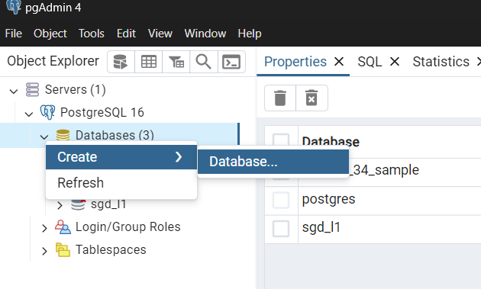

*2. Enter database name.*

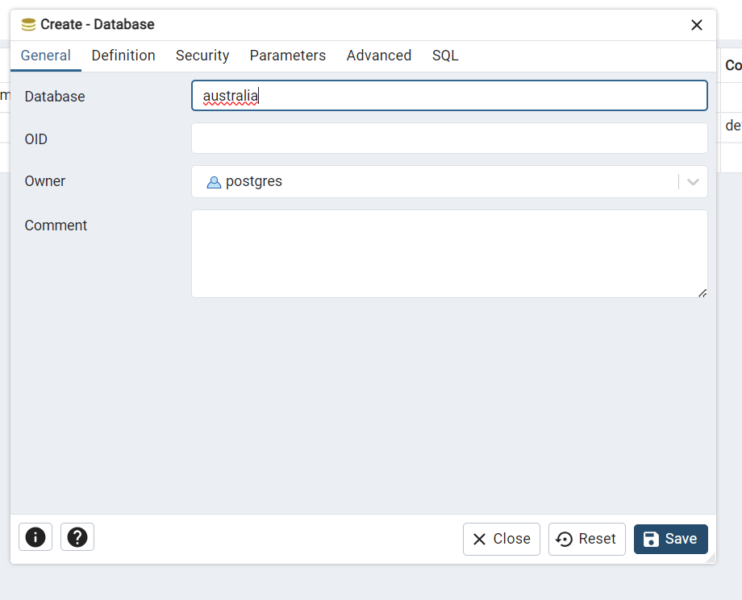

*● Under the new database create an extension using the following query*

*CREATE EXTENSION postgis;*

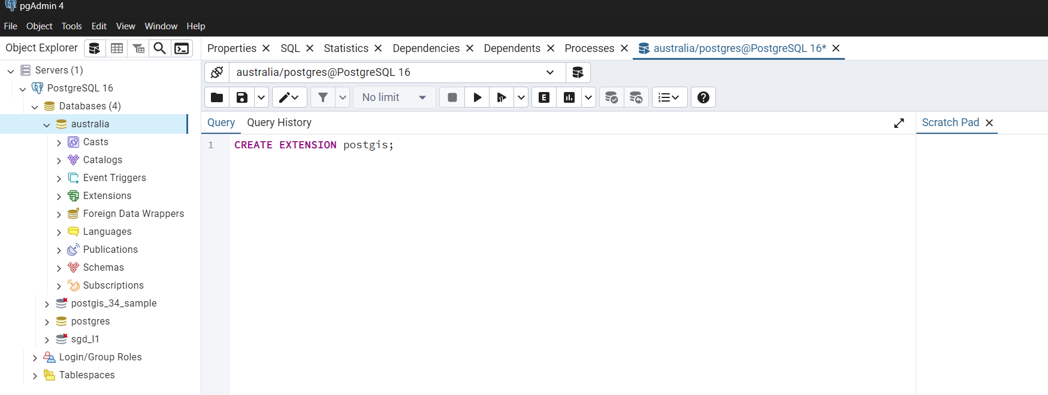 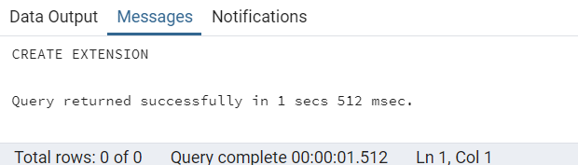

*● Create a new schema under owner postgres.*

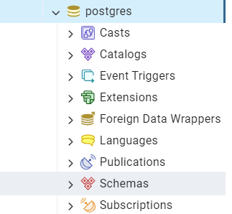 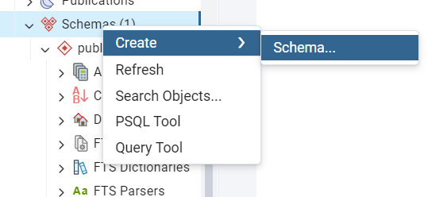

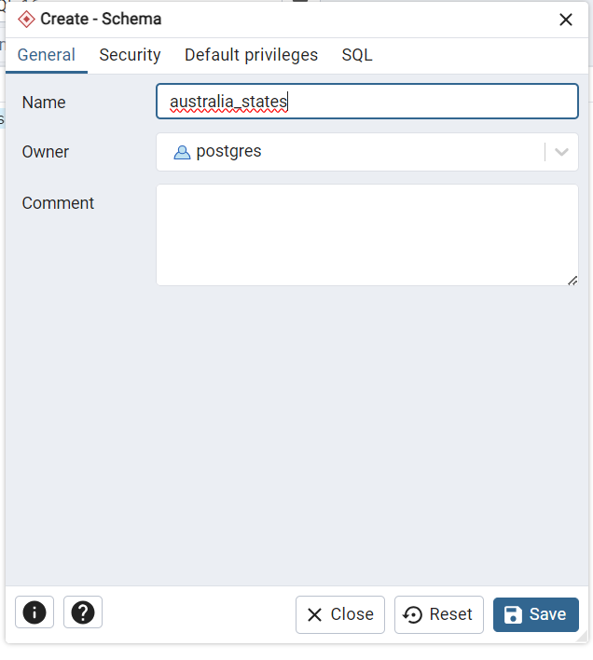

***we create “australia_states” as our schema here***

***B. Load data from a shapefile***

● Navigate to c:\Program Files\PostgreSQL\15\bin\postgis gui and run executable file shp2pgsql-gui.exe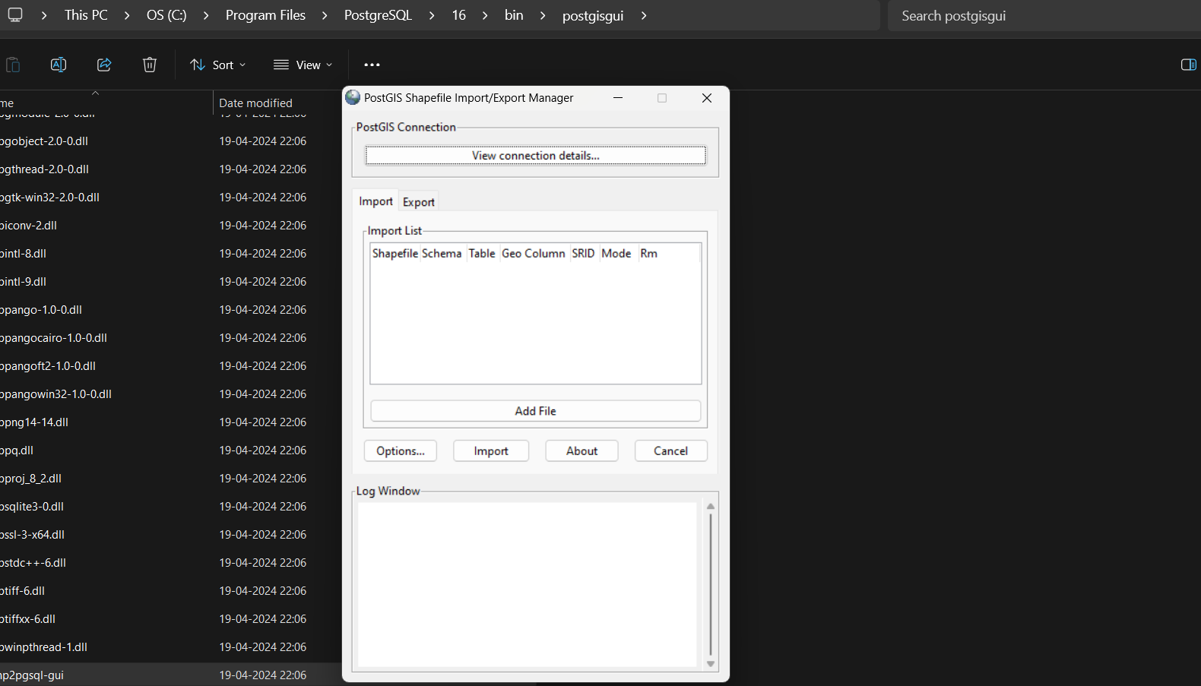

● Click on view connection details

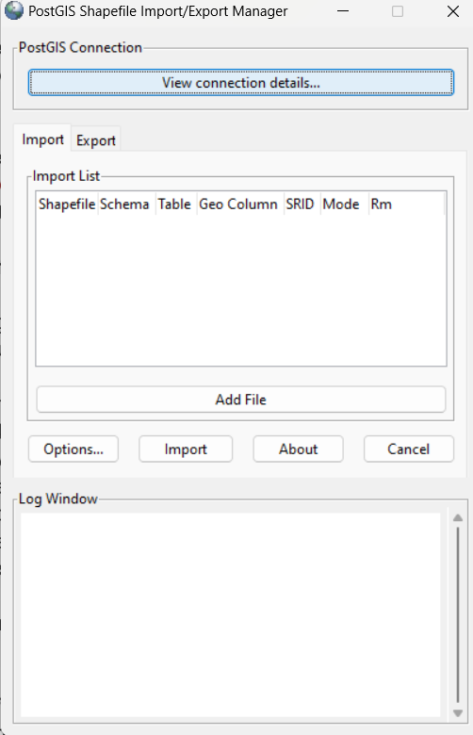

● Enter username as postgres, password, server host as localhost and port as 5432 and database name is the same as that was created above in step A.1. After clicking on OK, it should give a message connection succeeded.

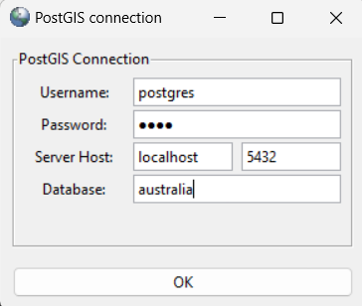 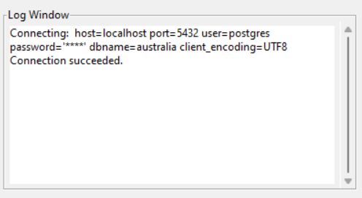

● Select the add files option and select the shapefile. 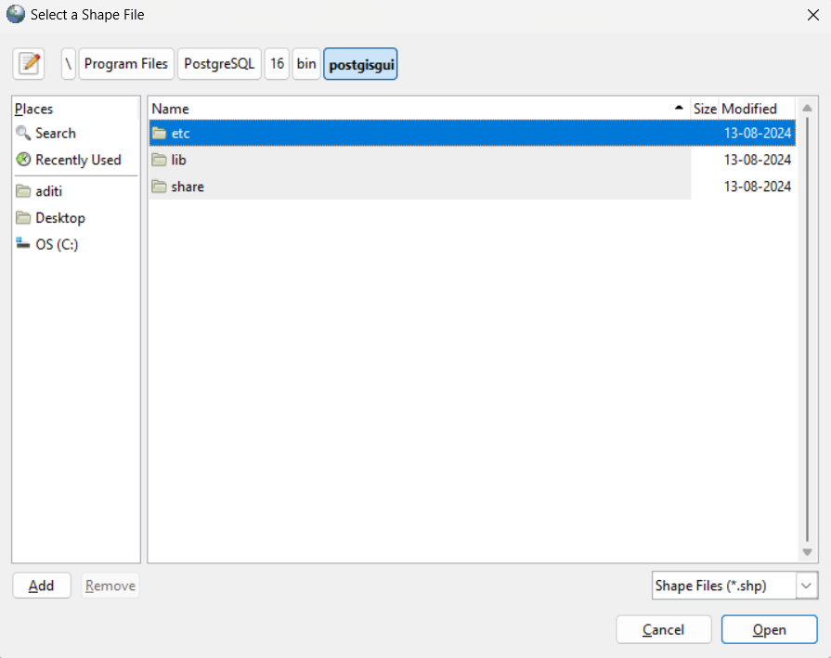

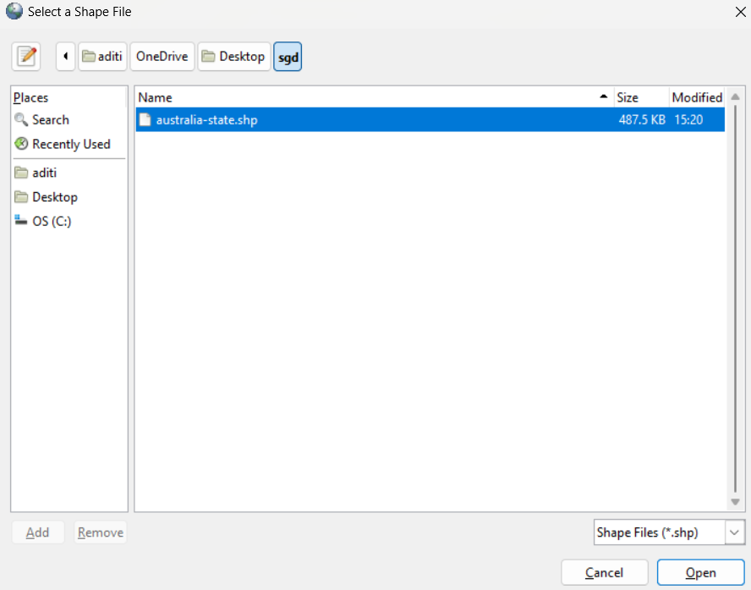

● In the import list set the schema parameter to public, table parameter to australia-state, geo column to geom and SRID to 4269. Now import the shapefile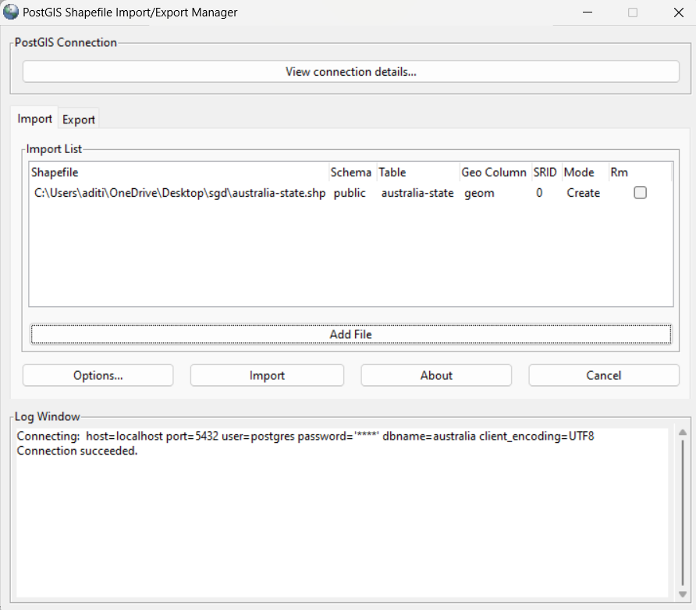 .

● Click on import and see the message in the log window. Query the data to ensure it has been imported correctly.

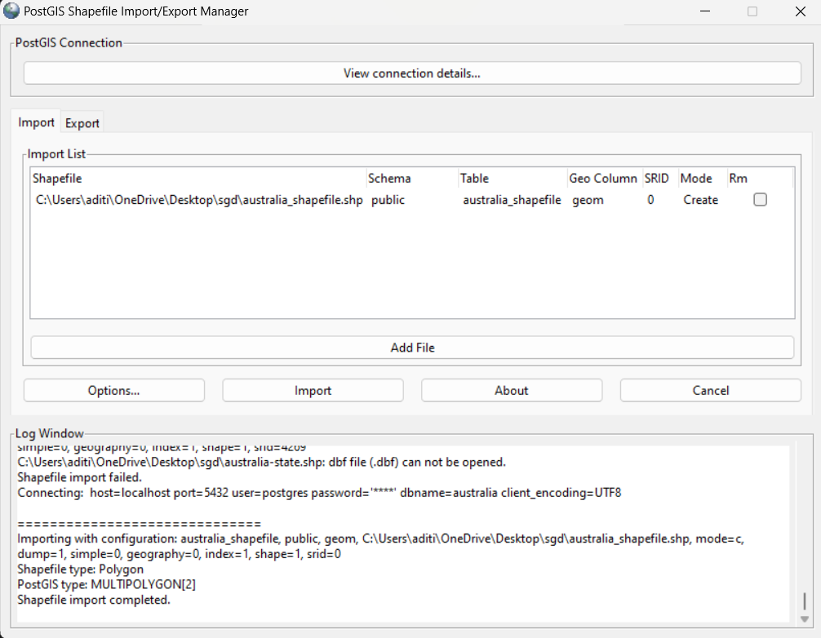

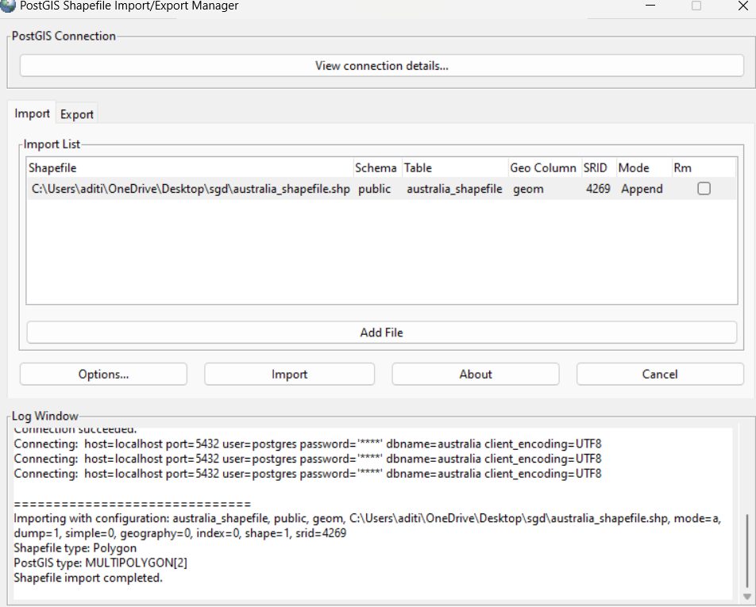

Shapefile is imported.

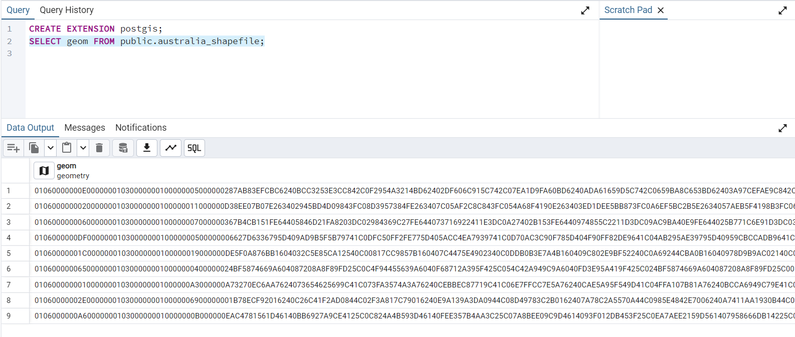

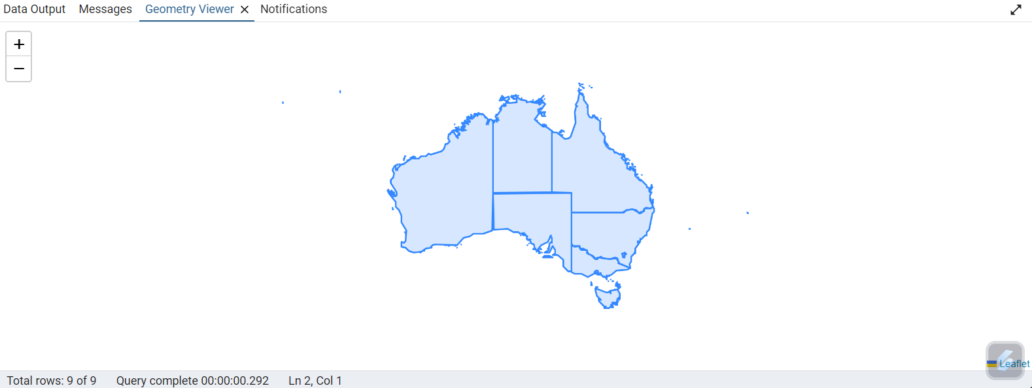

● Click on geom column map icon to visualize the map.

***C. Load data from CSV***

● Download the CSV file and view it in notepad. 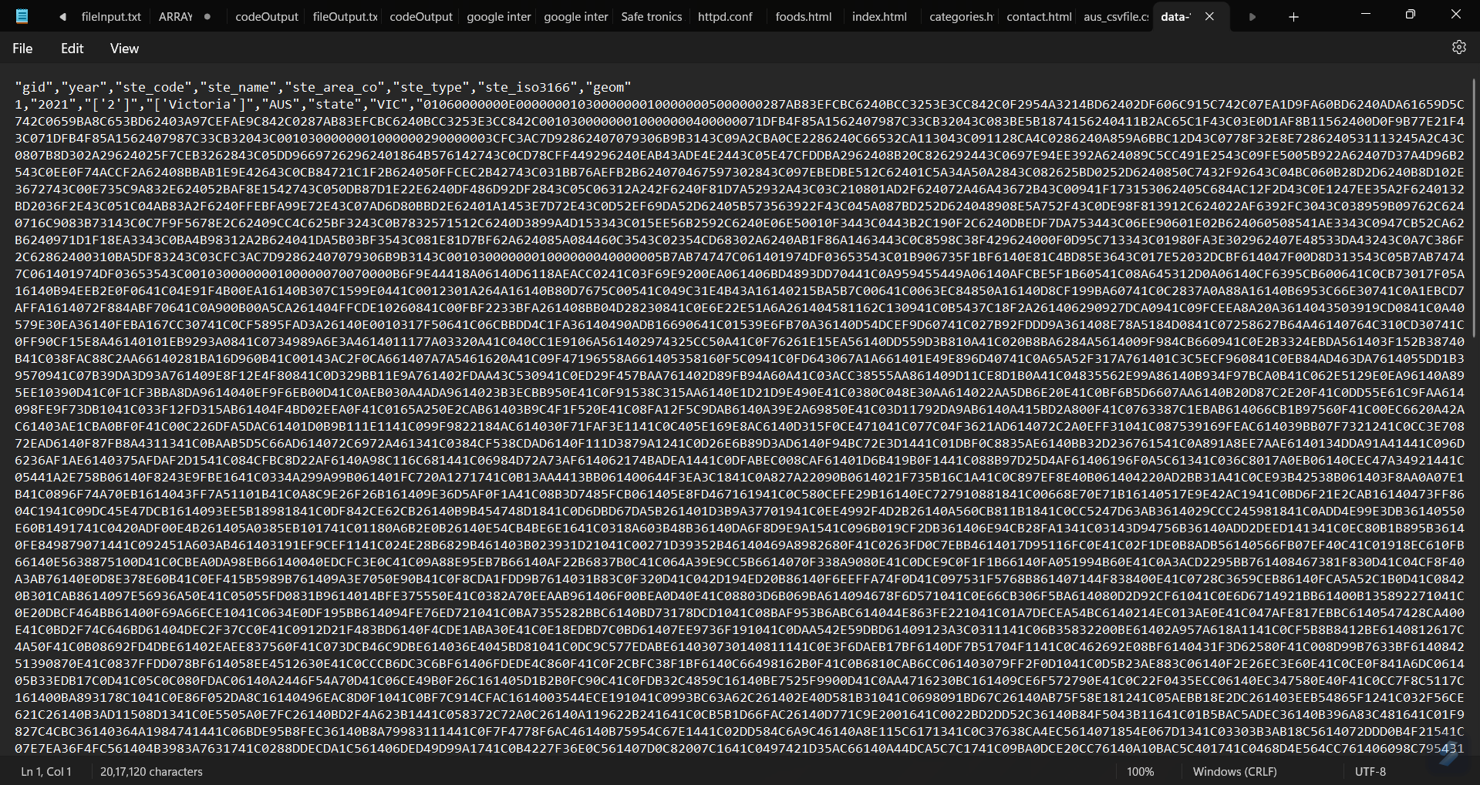

● Write a query to create a table with attributes as the column headers of the CSV file.

● Create a table for the CSV file in pgAdmin

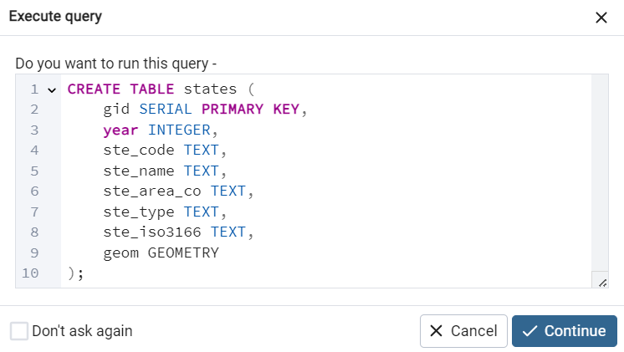

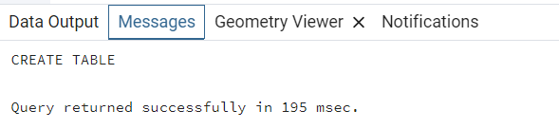

***D. Load data using COPY command***

**●** Import the data from the CSV file to pgAdmin using the copy command.

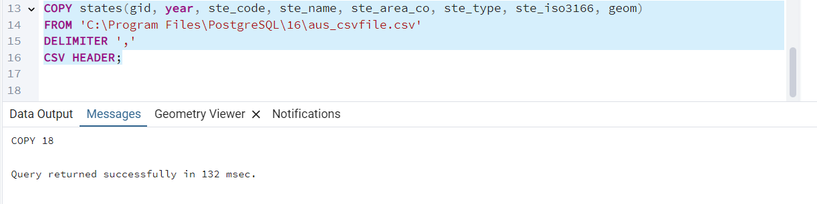

**●** Run a select query to check successful loading of data.

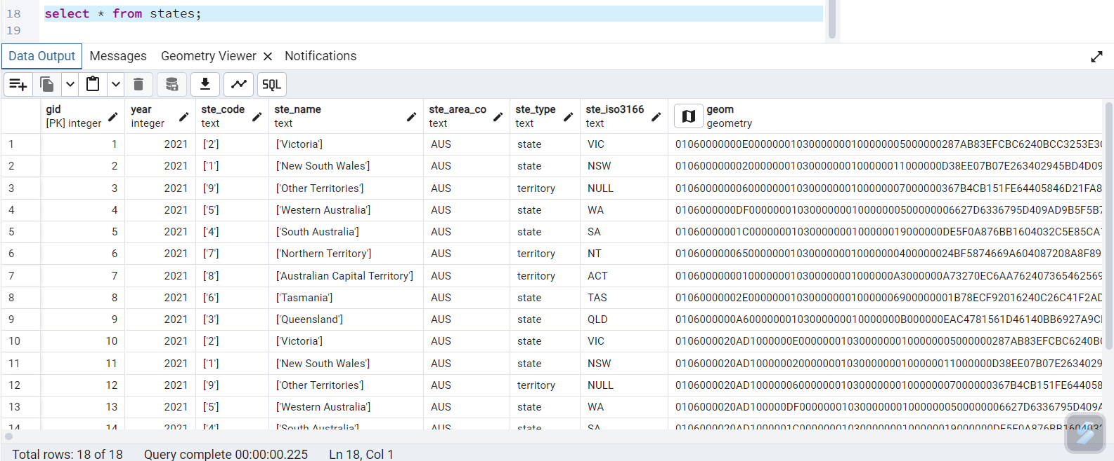

● Write queries in pgAdmin

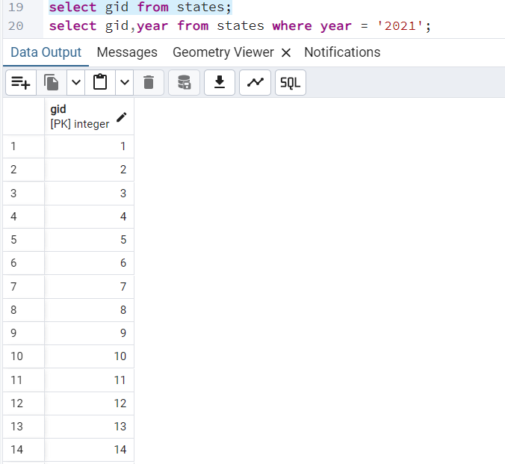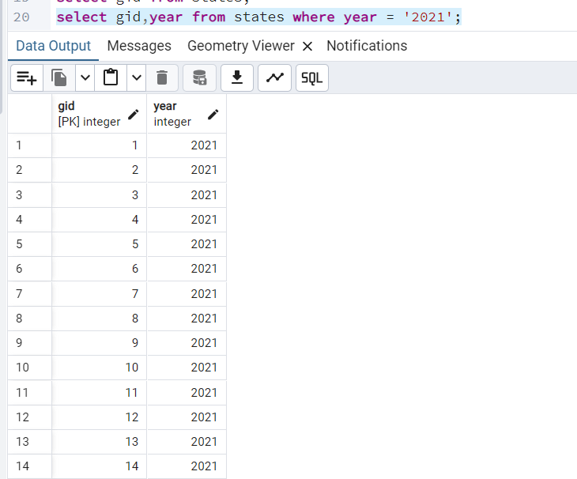

***Conclusion:***

*The process of importing a CSV file into PostgreSQL involves creating the appropriate table structure, ensuring the CSV file is properly formatted, and using the correct method to import the data. The `COPY` command is a powerful tool for server-side imports, but it requires that the file is accessible by the PostgreSQL server with appropriate permissions.*

*Key takeaways:*

*1. Ensure the CSV file is placed in a directory accessible by the PostgreSQL server.*

*2. The file path and permissions play a crucial role in the success of the import operation.*

*By following these steps, we successfully imported CSV data into PostgreSQL, ensuring that all data is loaded into the database for further use or analysis.*